JOIN DOHCAF!!!
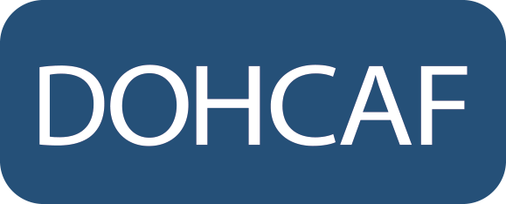  Dominican Health Care Association of Florida, Inc.  P.O. Box 145255, Coral Gables, FL 33114  +1-305-582-5794 · daisy@dohcaf.org |  |  |  |  |  | MEMBERSHIP APPLICATION
NAME |  | Last Name (or Company Name) |  |  |  |  |  | First |  | Initial
SPOUSE NAME |  |  |  |  |  |  |  | Referred by:
CREDENTIALS |  | ____MD ____DO ____DDS ____Not Applicable  ____Other ___________________________________ |  |  |  |  |  | SPECIALTY:
ADDRESS: |  | STREET ADDRESS |  |  |  |  |  | OFFICE #:
 |  |  |  |  |  |  |  | FAX #:
 |  | CITY |  |  |  |  |  | CEL #:
 |  | STATE |  | ZIP |  |  |  | E-MAIL:
GRADUATE or MEDICAL SCHOOL: |  |  |  |  |  |  |  | YEAR GRADUATED:
We would like for you to be an active member of our organization. Please let us know how you would like to be involved: |  |  |  |  |  |  |  | - Advisory Committee (various elective positions available)  - Educational Presenter  - Volunteer  - Other _____________________
Membership Level  (Please circle one) | MEMBER |  |  |  | AFFILIATE |  |  | MEDICAL STUDENT | GENERAL PUBLIC
 | MD, DO’s, and Dentists (DCMA membership not applicable for Dentists) |  |  |  | RN, PA’s, FMG, and all other health care professionals. |  |  | Must present valid ID | Anyone with an interest in supporting the organization
 | $200  06/01/2020-12/31/2021 |  |  |  | $100 per year  06/01/2020-12/31/2021 |  |  | $50  06/01/2020-12/31/2021 | $300 per year  06/01/2020-12/31/2021
Mail application along with dues to: | Dominican Health Care Association of Florida, Inc. (DOHCAF)  P.O. Box 145255, Coral Gables, FL 33114  or scan and e-mail to daisy@dohcaf.org
Form of Payment | Check |  | Credit Card
 | Check # _________  Amount $ _______  Date ___________ |  | - Visa  - Master Card  - American Express  - Discover |  |  |  | Card # ___________________________________  Expiration date _____________ CVV# _________  Name on the card if different from registration name _________________________________________
SIGNATURE
www.dohcaf.org The Dominican Health Care Association of Florida is also on FB and Instagram! @DOHCAF

All proceeds will benefit the Dominican Health Care Association of Florida, Inc. (DOHCAF), a 501(c)(3) Non Profit Corporation, Tax ID# 27-4582689, and its Mission to advance and promote the efforts of Health Care Professionals who embrace and support causes favorable to the Dominican community. A portion of your membership, ticket and/or sponsorship may be tax deductible. Consult your tax professional for final determination. DOHCAF is registered to solicit contributions with the State of Florida. A copy of the official registration and financial information may be obtained from the Division of Consumer Services by calling toll-free (800) 435-7352. Registration does not imply endorsement, approval or recommendation by the State.

